**Fundamentals of Data Science Final Project**



**Lecturer:**

**D6211_NUNUNG NURUL QOMARIYAH, S.Kom., M.T.I., Ph.D.**

**Arranged by :**

**2702345932_Daffa**

**2702357996_Edbert Tan**

**COMP6784001_Fundamentals of Data Science**

**Computer Science Faculty**

**Binus International University**

**Project name**Solar Power Plant optimization

**Name and Group Members:**

1. Daffa
2. Edbert Tan
3. **Problem Analysis**

As it stands, humanity’s constant use of fossil fuel has drained the earth of many resources, with the possibility of humans running out of it completely in the future. The issue is that humans keep using the non-renewable resources instead of the renewable ones. Renewable energy comes in many forms such as wind energy, geothermal energy, hydropower, bioenergy, ocean energy, and the main topic here, solar energy. Solar energy can be harnessed by using solar panels, which absorbs the energy from sunlight and creates electric charges from them. Like any solution, there is a way to optimize solar energy, in this case by placing them in a solar energy plant within areas with the most sunshine hours. However, there is also an issue with the solar panels where they will break more often when placed in areas with an average temperature higher than 25 degrees Celsius. To solve this, we have to place the solar energy plant in a place with the most sunshine hours while also making sure the average temperature does not exceed 25 by too much.

1. **related work**

<https://www.researchgate.net/publication/324840611_Potential_of_Solar_Energy_in_Indonesia>

<https://www.researchgate.net/publication/356513998_Study_of_Indonesia's_Solar_Energy_Implementation_Using_Identification_of_Potency_Policies_and_Cost-Benefit_Analysis>

<https://journals.itb.ac.id/index.php/joki/article/download/3917/1961>

• **Climate and Weather Data Analysis**: This involves the statistical analysis of climate data to understand patterns in weather conditions such as temperature, humidity, precipitation, and sunlight duration across different geographic locations.

• **Regional Comparisons**: Studies often compare weather data across regions, similar to the comparison of sunlight duration and temperatures in the sheet you provided.

• **Geospatial Analysis**: This type of data is frequently used in geographic information systems (GIS) to analyze spatial patterns in weather data.

1. **Dataset and Reprocessing**

average sunshine hours per area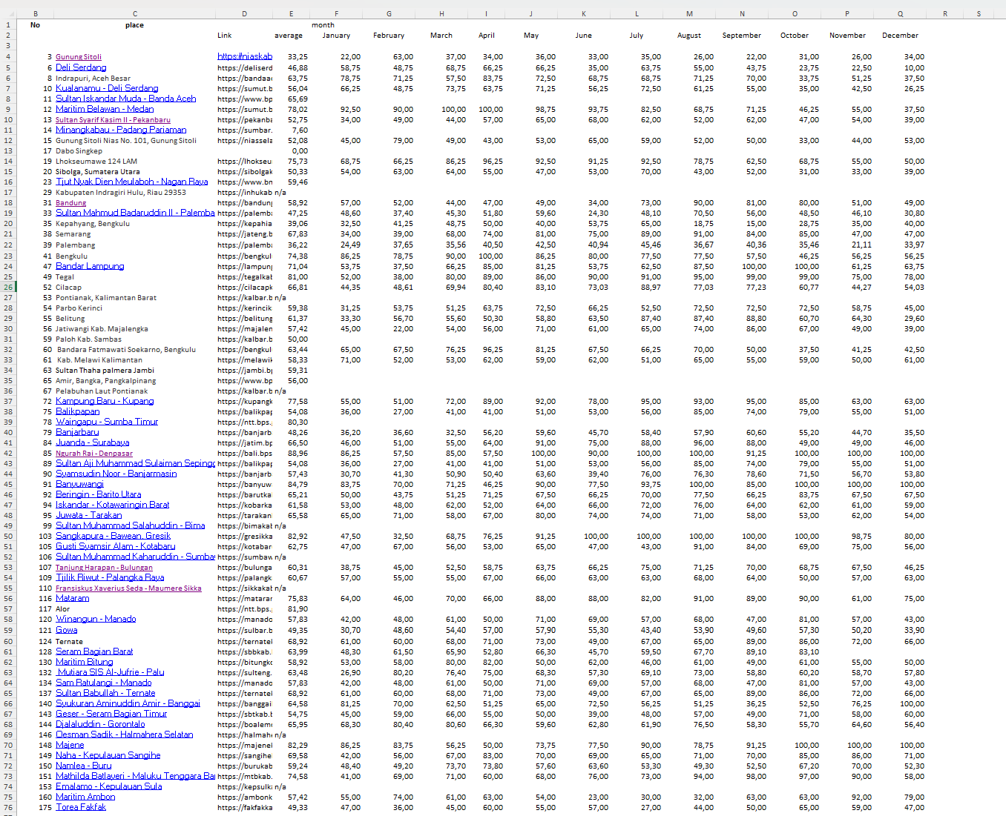

average area temperature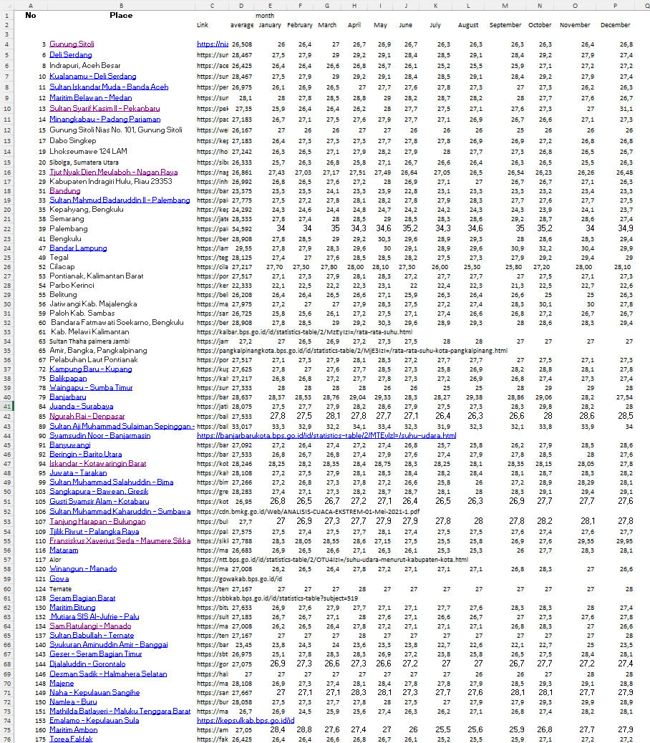

sorted without removing places with unavailable data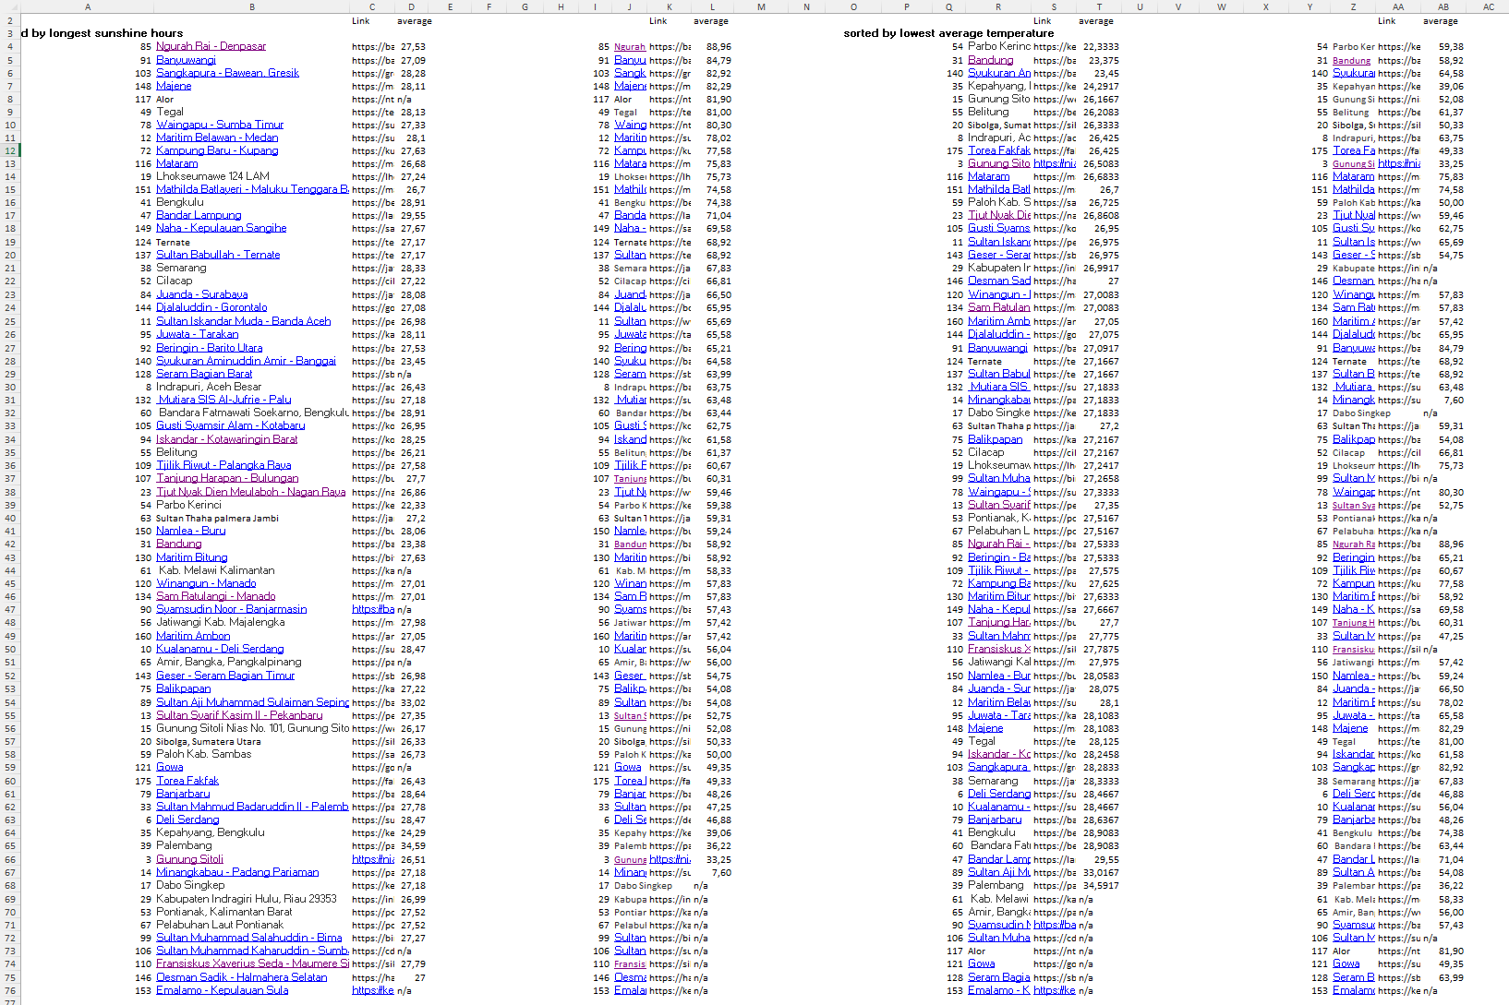

sorted and removed places with unavailable data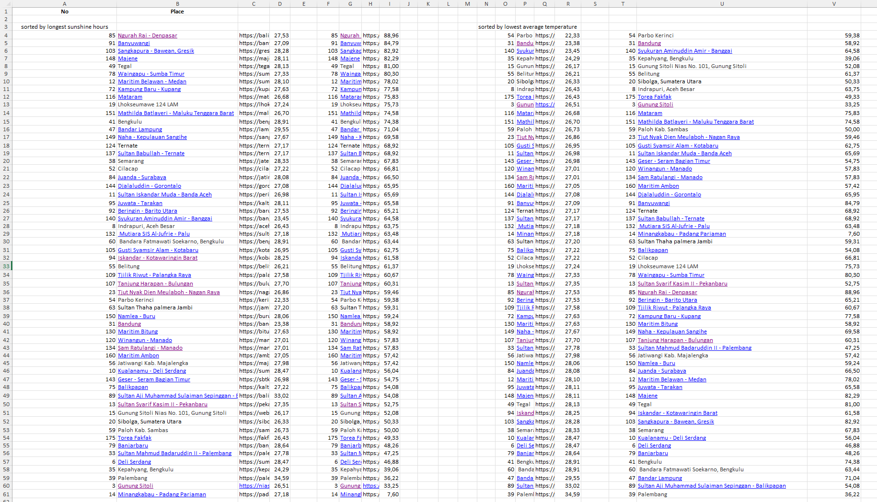

1. **Model and Techniques**

-using google colab to visualise data  
-using powerbi to visualise data

• **Time Series Analysis**: This can be used to analyze trends in temperature or weather conditions over time for each region.

• **Cluster Analysis**: Geographic locations with similar weather conditions might be grouped together using clustering techniques like K-means.

• **Regression Models**: These can be used to predict future weather patterns based on historical data.

• **GIS and Spatial Analysis**: Tools like ArcGIS or QGIS are used to map and analyze the spatial distribution of weather data, comparing regions.

• **Machine Learning**: More advanced techniques like random forests or neural networks could be used to model and predict complex weather patterns across different regions.